**Elevate Product Showcase with Enhanced Camera Operations in VisCommerce's 3D Room Planner Tool**

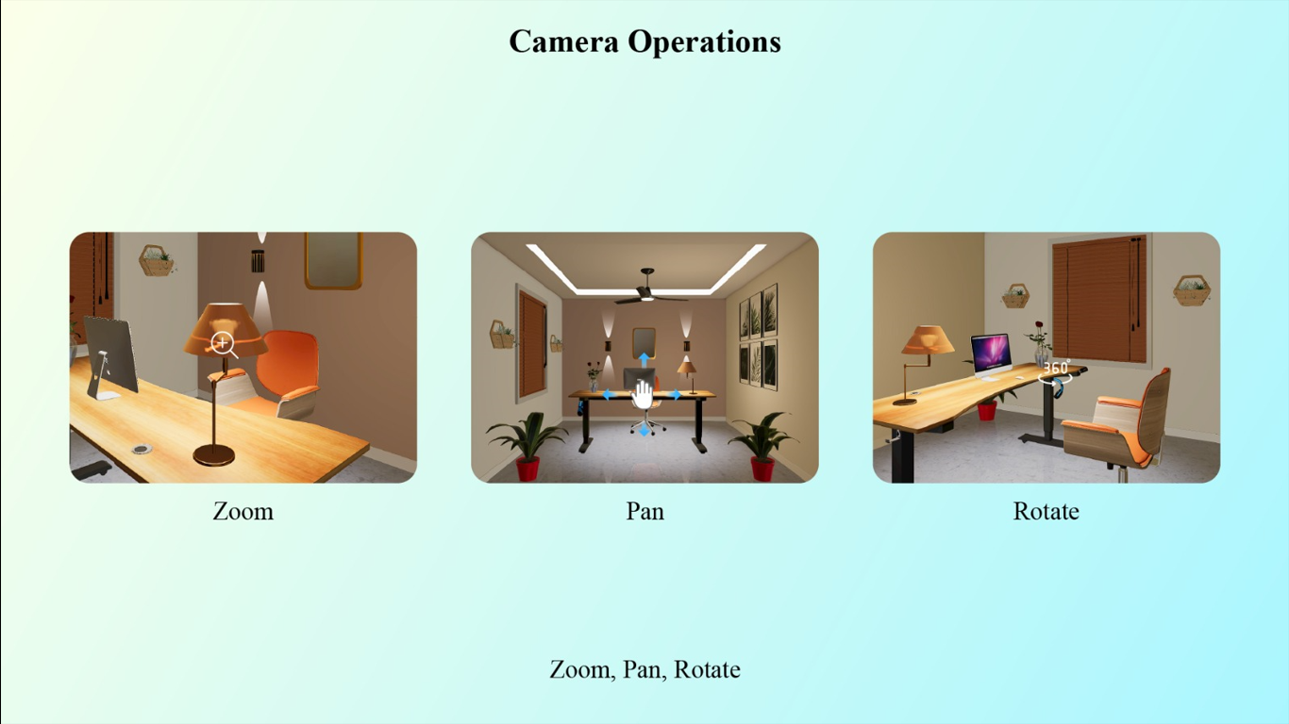

Subject: Elevate Product Showcase with Enhanced Camera Operations in VisCommerce's 3D Room Planner Tool

Dear [Recipient's Name],

I hope this email finds you well. I wanted to discuss a fascinating aspect of VisCommerce's 3D Room Planner Tool that promises to take our product presentation to new heights. The tool's advanced camera operations, including zoom, pan, and rotation, offer an unparalleled level of interaction, allowing us to showcase products in stunning detail within both home and store 3D environments.

In the dynamic world of e-commerce, offering a visual experience that closely mimics an in-person encounter is paramount. The camera operations in VisCommerce's 3D Room Planner Tool empower us to create immersive and engaging presentations that captivate our customers. Here's how these camera operations can transform our product showcasing:

* **Zoom for Detail:** The ability to zoom in on a product allows customers to explore intricate details that might go unnoticed otherwise. Whether it's the texture of fabric, the craftsmanship of a piece, or any unique features, the zoom functionality ensures that users can fully appreciate the finer aspects of our products.
* **Fluid Pan Movement:** With the pan feature, users can navigate through the 3D environment, seamlessly moving from one corner of the room to another. This feature is particularly useful for showcasing products within the context of a larger space, giving customers a sense of how items fit into their overall design vision.
* **360-Degree Rotation:** The ability to rotate the camera and view products from various angles provides a comprehensive understanding of their dimensions and aesthetics. Customers can inspect products as if they were physically turning them around, fostering a deeper connection and understanding of the items.
* **Interactive Store Layouts:** For our store environments, these camera operations offer a virtual walkthrough experience. Customers can virtually stroll through the store, examining products from different angles, just as they would during an in-person visit. This level of interaction bridges the gap between online and offline shopping experiences.
* **Enhanced Customer Engagement:** By offering these camera operations, we can boost customer engagement and interaction with our products. The immersive nature of the tool encourages customers to spend more time exploring, leading to increased customer satisfaction and potentially higher conversion rates.

I am genuinely excited about the possibilities that VisCommerce's 3D Room Planner Tool's camera operations bring to our product showcasing efforts. These features not only provide an enhanced online shopping experience but also enable us to replicate the tactile engagement customers seek when shopping in physical stores.

If you're interested in learning more about these camera operations and how we can seamlessly integrate them into our existing strategies, I'd be delighted to provide further insights or arrange a demonstration.

Thank you for your time, and I look forward to hearing your thoughts.

Best regards,